A COMPARATIVE STUDY FOR PROPELLER BLADE DESIGN

Engenharia Térmica (Thermal Engineering),

Vol. 15 • No. 2 • December 2016 • p. 30-37

This paper’s main objective is to compare two main ways of designing a propeller blade, a graphical method that has been developed for application on amateur aviation and a mathematical method based on the Blade Element Theory (BET) in combination with Momentum Conservation Theory.

The first design method uses mostly “nomographs”, set graphs that tell you the optimum value for a predefined parameter. For example: For a new blade, lines are drawn (manually) connecting three input parameters: engine power, engine speed and flight speed. As outputs, the method provides the propeller diameter, pitch and efficiency. However, the author himself affirms that the blade profile is not a parameter to be considered on this design, therefore this method will only be a comparison factor during the study of the article.

The second design method uses a program that employs the BET, called *JavaProp* and was chosen based on a study developed by Barbosa (2009) and considered adequate for the application. The method consists of feeding the program information such as engine power, engine speed (rpm), flight speed, number of blades, propeller diameter, spinner diameter, air density, kinematic viscosity and speed of sound to obtain optimum parameters of chord length and twist angle for each blade element considered, always looking for the most efficiency.

After researching about the Freeware *JavaProp* and trying to simulate the results presented by the paper, another factor was found that the article didn’t mention directly. The airfoil is a main point of design for the second method. The preset of a commercial propeller may mean that the author loaded the official airfoil of that propeller to the program, but didn’t mention it on the paper. So the flowchart for the paper looks like this.

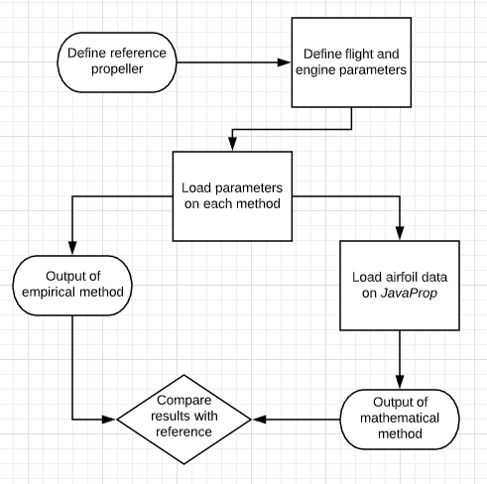

For an application on our research, the freeware *JavaProp* could be used as it optimizes the efficiency of the propeller. A possible application would consist of the following flowchart:

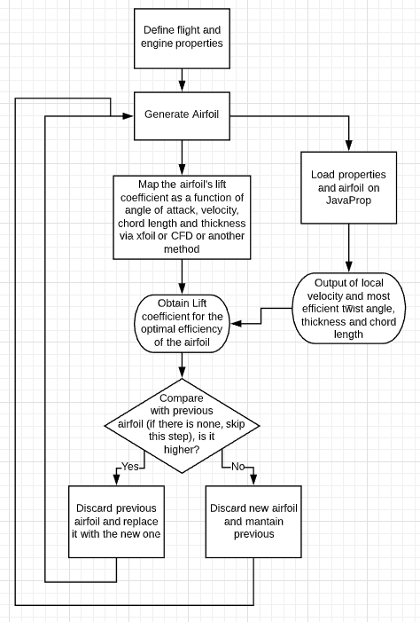

Considering that there actually is a range of flight and engine properties, several chains of this flowchart are going to take place and the general conclusion of the process is going to demand a lot of computational processing and time.

Conclusion, the flowchart looks promising but it is going to take a lot of processing and time to take place.

*Barbosa, F. R., 2009, Design and Analysis on Performance of Optimum Propeller Applying Genetic algorithm, Master Thesis, ITA, São José dos Campos, SP.*